RetailIQ – Full-Cycle E-Commerce Customer & Sales Analytics
n

Abstract— With the rapid increase in e-commerce platforms, large amounts of customer data and sales data have been generated. Therefore, there is a need for a way of understanding customer purchase behaviour and determining which customers have value. This paper proposes RetailIQ that uses data analytics and machine learning techniques to analyse customer behaviour and sales within an e-commerce setting. The data used comes from the Indian E-Commerce Customer Behavior and Purchase dataset containing 25,000 records and 29 attributes. Data pre-processing and Exploratory Data Analysis was performed to gain an understanding of purchase behaviour, sales trends, and cart activity. RFM (Recency, Frequency, Monetary) analysis was performed to extract features about customers, giving 4176 customers who had made at least one purchase. K-Means and Agglomerative Clustering were performed and evaluated on Silhouette Score, Davies-Bouldin Index, and Calinski-Harabasz Score. From this, the K-Means algorithm was chosen to provide the best overall results with 5 clusters, providing 5 different groups of customers. Principal Component Analysis was performed to provide a 2D visualisation of the customer clusters with 85.32% variance explained. An interactive dashboard was created using streamlit to display the analytics, customer segments, model evaluation and recommendations. The system provides insights into the data which can be used to help retain customers, target marketing and make data driven decisions within e-commerce.
Keywords— E-commerce Analytics, Customer Behaviour Analysis, Exploratory Data Analysis, RFM Analysis, K-Means Clustering, Agglomerative Clustering, Customer Segmentation, Principal Component Analysis, Streamlit Dashboard.

Introduction
With the rise of e-commerce, there is an increase in the creation of data due to consumer interaction with online shops, shopping carts and purchases. The data can provide useful insights on consumer behaviour and sales performance. However, this can only be done by analysing the data. To extract useful insights and create clear segments from large data sets.

A useful method to segment customers is to group together those with similar purchase behaviours. A common method used to analyse customer data is RFM analysis. This takes into account Recency – how recently the customer made a purchase, Frequency – how often they made a purchase and Monetary – how much they spent. Clustering algorithms can be used to create segments based on RFM features.

In this paper we will look at how we can analyse customer behaviour and sales data using data analytics and machine learning methods. We will focus on the Indian E-Commerce Customer Behavior and Purchase dataset. This dataset consists of 25,000 records and 29

attributes. Preprocessing and Exploratory Data Analysis (EDA) was carried out to understand consumer behaviour, purchase behaviour, revenue and shopping cart behaviour. RFM analysis was carried out on 4,176 customers with at least one complete purchase to create features for the customer.

K-Means and Agglomerative clustering algorithms were implemented to create segments for customers. Both models were compared using the Silhouette Score, Davies-Bouldin Index and Calinski-Harabasz Score. It was decided that K-Means with 5 clusters would be the best model to create segments. Although K-Means with 2 clusters gave a higher Silhouette score, it didn’t perform as well with the Davies-Bouldin and Calinski-Harabasz scores. The 5 cluster model had more detailed segments. Principal Component Analysis was carried out to reduce the preprocessed RFM features into 2 dimensions. This explained 85.32% of variance.

An interactive dashboard was created using Streamlit to show an overview of the dataset, customer segments, model evaluation and visualisations. The focus of this project was to analyse historical e-commerce data and create insights at a customer level to aid customer retention, targeted marketing and data driven decisions.

LITERATURE REVIEW
Customer Segmentation has been studied extensively and is an important method for understanding customer behaviours. Many techniques such as statistical and machine learning techniques have been used to determine customer segments. An example of popular techniques are RFMs and clustering.

Anitha and Patil [1] created a customer segmentation model using RFMs and the K-Means clustering algorithm. The paper used Recency, Frequency, Monetary values to understand customer segments using transaction history. The Silhouette Coefficient was used to validate the clusters. By using RFMs alongside K-Means clustering this has shown that it is useful to understand customer purchase behaviours.

[1] Springer Nature Link

Gomes and Meisen [2] provided a detailed overview of customer segmentation. They looked at 105 publications and saw that RFMs and K-Means are commonly used to segment customers. This paper looked at the importance of the customer segmentation process and found that RFM is commonly used to represent customer behaviours. K-Means is one of the most widely used clustering algorithms.

[2] Springer Nature Link

Salminen et al [3] performed a systematic literature review of customer segmentation using algorithms. They looked at 172 relevant papers finding that there were 46 different algorithms and 14 evaluation measures used within customer segmentation. They found that K-Means was the most common clustering algorithm. It was also highlighted that it is important to use appropriate algorithms, decide on the number of clusters and evaluate them.

[3] Springer Nature Link

Rousseeuw [4] created the Silhouette method which provides a visual way to understand and validate the clustering results. The method looks at how similar the observations are to their assigned cluster and how different they are to the adjacent clusters. The mean Silhouette Score can be used to understand the quality of the clusters and help find the right amount of clusters.

[4] ScienceDirect

From the previous studies it can be seen that RFMs and K-Means clustering can be used as a basis for customer segmentation. However it can be seen that using the right clustering algorithm and number of clusters can affect the quality of the results. It is important to look at the clustering algorithms using multiple internal validation measures.

The proposed RetailIQ system applies these techniques. The system performs data preprocessing, EDA and RFM. The system uses K-Means and Agglomerative Clustering and compares them using the Silhouette Score, Davies-Bouldin Index and Calinski-Harabasz Score. The Principal Component Analysis technique was also used to visualise the data in 2-D. The customer segments, results and recommendations for businesses can be viewed in the Streamlit dashboard.

Research Gap
In existing literature, RFM analysis and clustering techniques have been shown to be effective for segmenting customers by purchase behaviour. We want to create an integrated system that allows us to perform customer behaviour analytics, sales analytics, customer segmentation and interactive visualisation.
Research Gaps:

- Lack of integration of techniques. In existing approaches only one analytical technique has been used. In this project we want to integrate data cleaning, EDA and RFM analysis.
- Lack of comparison of clustering techniques. Different clustering techniques can give different customer segments. To understand how well each algorithm performs, we will compare the K-Means and Agglomerative Clustering algorithm using the same RFM data.
- Lack of full model evaluation. Using one metric may not fully evaluate the quality of the clusters. Therefore using the Silhouette Score, Davies-Bouldin Index and Calinski-Harabasz Score will give us a wider view.
- Lack of visualisation of customer segments. If we do not use visualisations, it can be hard to understand the analytics. Using PCA we can reduce the dimensions to 2 and see how the customer clusters are distributed.
- Lack of easy to understand insights. The customer segments will be much more useful if they can be easily understood. Having an interactive dashboard means it will be easy to understand the customer segments, sales stats, evaluation results and business insights.

PROPOSED METHODOLOGY
The following method will be used by RetailIQ to assess the behaviour and sales performance of their customer base by utilizing techniques from data analytics and Machine Learning. The first step would be to gather the data, then pre-process the data. Then we perform an Exploratory Data Analysis (EDA). We then run an RFM analysis. Finally, we can evaluate our model, apply dimensionality reduction and create a dashboard.
A. Data Gathering
The Indian E-Commerce Customer Behavior and Purchase dataset was gathered from Kaggle. There are 25,000 samples and 29 features which represent customer, browsing, shopping cart and purchase information. The dataset is in CSV format and was loaded into Python using the Panda library.
B. Data Pre-processing
We will look at our gathered data and pre-process it. This will allow us to see any issues with the data such as the data type, any missing values and duplicates. We will also prepare the relevant features for the EDA and RFM analysis per customer.
C. Exploratory Data Analysis
The EDA is conducted so we can get an understanding of what our dataset looks like. We will carry out some statistical analysis and visualisations to understand the distribution of customers, purchasing behaviour, revenue, shopping cart activity and numerical distributions. This will help us understand what trends are important.
D. RFM Analysis
The RFM analysis will be carried out to understand the purchasing behaviour of the customers. This will be done by looking at:
Recency (R): How many days ago the customer last purchased.
Frequency (F): How many times the customer has purchased.
Monetary (M): How much the customer has spent.
The RFM scores will be calculated per customer. This will only include customers that have made at least 1 purchase. This will give 4176 customers to segment. This will be used as the input to our clustering algorithm.
E. Feature Scaling
The RFM features will be scaled so they can be used in the clustering algorithm. Since the Recency, Frequency and Monetary values will be on different scales we need to scale our features so we don’t have any large variables dominating our distance metrics.
F. Customer Segmentation
We will implement two unsupervised machine learning algorithms to segment our customers.
K-Means: Will create clusters based on the nearest centroid. We will look at creating 2 clusters and 5 clusters.
Agglomerative: Will create clusters using a hierarchical method based on the similarity of the RFM values. We will implement 5 clusters.
Once we have created our clusters we will look at what the clusters look like using the RFM values. We will also give them meaningful names.
G. Model Evaluation
We will assess our clustering algorithms by looking at:
Silhouette Score: This will tell us how well our customers fit into the clusters they have been placed in. The higher the value the better defined the clusters are.
Davies-Bouldin Index: This will tell us how similar the clusters are. The lower the value the better defined the clusters.
Calinski-Harabasz Score: This will tell us how well separated our clusters are based on the ratio between the dispersion between clusters to the dispersion within clusters. The higher the value the better defined the clusters.
We will compare the results of our model evaluations to choose a suitable model for our segmentation. We chose to use K-Means with 5 clusters as it had the best results overall and the extra detail in the segments was useful.
H. Dimensionality Reduction
We will perform Principal Component Analysis (PCA) on our preprocessed RFM features to reduce them to 2 principal components. These will explain 85.32% of the variance. We will use these to visualise our customer clusters. However, we won’t use this as the input to our final model.
I. Dashboard
A dashboard has been created using Streamlit to show the results of our analysis. The dashboard shows information about the dataset, sales, customer segments, model comparisons, visualisations and recommendations. This gives us an easy way to view our results.
J. Business Insights and Recommendations
We will interpret our final customer segments to understand which customers are high value, frequent, recent and risky. We will give recommendations based on their purchasing behaviour to retain customers, target market, encourage repeat purchases and engage customers.

Overall, we have used data analytics, RFM customer analysis, clustering algorithms, model evaluation and visualisation to give meaningful insight into customer behaviour and sales.

PROPOSED IMPLEMENTATION
The implementation of RetailIQ aims to produce insight into the customers and sales of the dataset we have collected by using data analysis techniques and machine learning. This has been implemented using Python and its data analysis and machine learning libraries alongside Streamlit.

A) Development Environment

This project was implemented using Python in the Anaconda environment. Jupyter Notebook was used to analyse the data and build our models. The following libraries were used:

Pandas – To load our dataset and help with preprocessing.
NumPy – To help with numerical operations.
Matplotlib/Seaborn – To visualise our data.
Scikit-learn – For feature scaling, clustering algorithms, PCA and model evaluation.
Streamlit – To create our dashboard.

B) Load and Preprocess Dataset

Our dataset (Ecommerce.csv) was loaded into a Pandas dataframe. After exploring the dataset we can see that there are 25,000 rows and 29 columns. We can see there are no duplicated rows, and the data has been preprocessed to help with future analysis.

C) Exploratory Data Analysis

An exploratory data analysis has been conducted to gain insight into how our customers are behaving and how our sales are performing. By generating statistical summaries and visualisations we can get an understanding of how our customers are distributed, what they are purchasing, how much revenue we are making and how many items are being added to carts.

There are 8,442 unique customers in our dataset. There are 5,616 completed purchases meaning 22.46% of customers made a purchase. There is a total revenue of 10,116,169.06. We can see there are 16,117 items added to carts, however 10,501 have been abandoned meaning 65.15% of carts have been abandoned.

D) Generate RFM Features

An RFM analysis was conducted to help generate features for each customer. Recency is the time since the customer last purchased, Frequency is how many times they have purchased and Monetary is how much they have spent. We looked at 4,176 customers who had made at least one completed purchase. This has resulted in an RFM dataset which will be used for customer segmentation.

E) Implement Clustering Algorithms

Two clustering algorithms were implemented using scikit learn.
K-Means Clustering – Multiple different configurations of clusters were tried to find appropriate customer groupings. Two and five clusters were trialled.

Agglomerative Clustering – A hierarchical clustering algorithm was implemented using five clusters. This can be compared to our K-Means results.
The RFM features were scaled prior to implementing the clustering algorithms. We can then look at how the clusters have been formed based on the RFM features for each customer.

F) Model Evaluation

The clustering models were evaluated using three different metrics. This allowed us to compare how good our clusters are.
K-Means with five clusters achieved a Silhouette Score of 0.39920, Davies-Bouldin Index of 0.9688 and Calinski-Harabasz Score of 2622.5918. Whilst the two cluster K-Means model achieved a slightly higher Silhouette Score of 0.41910, it does not perform as well in the other two metrics. Using five clusters has provided a more detailed customer segmentation so we will use this as our final model.

G) Principal Component Analysis

We reduced our preprocessed RFM features using Principal Component Analysis. This reduced our data to two dimensions. We can see that the first two principal components explain 85.32% of the variance. We can now visualise our clusters in two dimensions to see how our customers are distributed between our identified segments. Our final clustering model still uses our original RFM features.

H) Identify Customer Segments

Our final K-Means model has identified five customer segments:
- High Spending Risky Customers
- High Value Regular Customers
- Inactive/Risky Customers
- New Recent Customers
- Repeat Customers
Each segment has been analysed to understand their purchasing behaviours and how important they may be to the business.

I) Create Streamlit Dashboard

A Streamlit dashboard has been created to visualise our results. This dashboard has the following sections:

Overview – Gives key statistics about our dataset and sales.
Customer Segmentation – Shows the five customer groups.
Model Evaluation – Shows and compares the metrics for our clustering models.
Visualisations – Shows our analytical charts and customer clusters.
Business Recommendations – Shows recommendations based on our identified customer segments.

The overall workflow of the proposed RetailIQ approach is shown in Fig. 1.
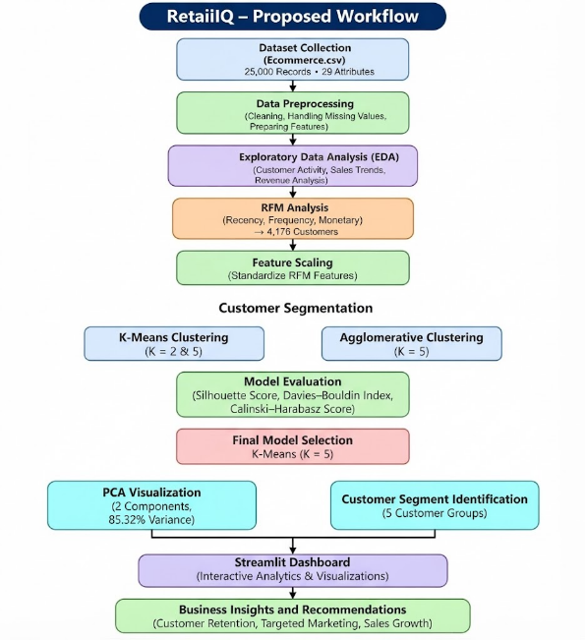
Fig. 1. Proposed RetailIQ workflow.
.

EXPECTED RESULTS AND OUTCOMES
The proposed RetailIQ project will provide a comprehensive insight into how customers behave when using e-commerce by using data analysis and machine learning. This will allow:
A. Better Understanding of Customer Behaviour
Customer behaviour such as purchase patterns, shopping basket behaviour, purchase frequency and spend patterns will be identified using Exploratory Data Analysis.
B. Customer Segmentation
By using RFM analysis and K-Means Cluster Analysis we can group customers based on purchase patterns. Our final model will have 5 clusters which will divide our customers into different segments including high value, frequent, recent single time and risk customers.
C. Identify Valuable and Risk Customers
The segmentation will allow us to identify customers who will bring in a lot of revenue and those who may need to be engaged with more.
D. Compare Clustering Models
Using K-Means and Agglomerative clustering and evaluating using Silhouette Score, Davies–Bouldin Index and Calinski-Harabasz Score we will gain an understanding of how the clustering models performed and choose a suitable model.
E. Dimensionality Reduction
PCA will allow us to reduce the dimensionality of our RFM features to 2 so they can be visualised. We will be able to observe how the customers were distributed and separated by looking at the clusters.
F. Dashboard
The Streamlit dashboard will provide an easy to use interface allowing us to view statistics from the data set, customer segments, model evaluation, visualisations and business recommendations.
G. Business Decision Making
The insights provided by the system will allow e-commerce businesses to create targeted marketing strategies. This can improve engagement with customers encouraging them to make repeat purchases.
H. An e-commerce analytics system
Overall we will have an integrated analytics system which will take previous customer/sales data and provide insightful information. Using Preprocessing, EDA, RFM Analysis, Clustering, Model Evaluation and Visualisation we will be able to provide the business with data driven decision making. This will increase our understanding of customer purchase behaviours.

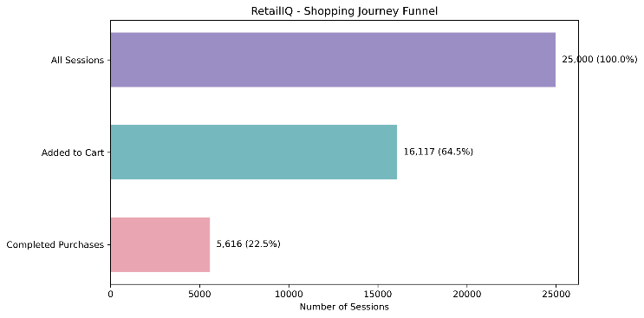
Fig. 2. Shopping Journey Funnel
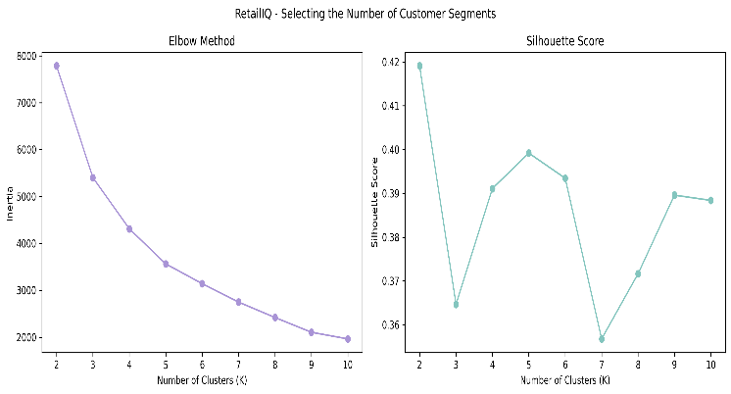
Fig. 3. Optimal Cluster Selection
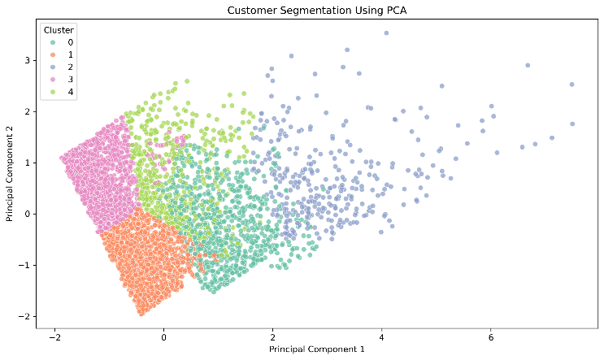
Fig. 4. RFM Clusters PCA
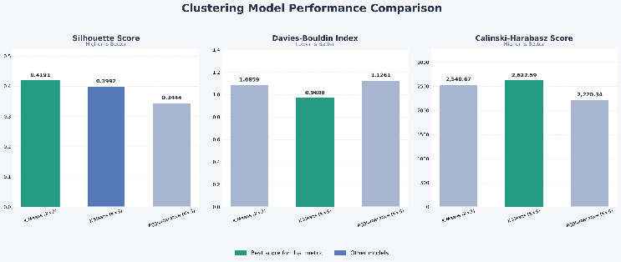
Fig. 5. Clustering Model Performance Comparison

CONCLUSION
RetailIQ - Full Cycle E-Commerce Customer & Sales Analytics is a project which aims to utilise data analytics and machine learning to provide an integrated solution for analysing customer behaviours and sales within e-commerce. The Indian E-Commerce Customer Behavior and Purchase dataset has been used to analyse the customer activity, purchase behaviour, revenue distribution and shopping basket behaviour through data cleaning and Exploratory Data Analysis.

RFM analysis was carried out to determine customer purchase behaviours based on Recency, Frequency and Monetary values. K-Means and Agglomerative clustering were implemented to segment customers. The performance of both was assessed using Silhouette Score, Davies-Bouldin Index, and Calinski-Harabasz Score. Based off the overall assessment of the models, it was decided to implement K-Means with 5 clusters. This identified 5 unique customer groups. To visualise the clusters PCA was implemented, capturing 85.32% of the variance.

A Streamlit dashboard was created to provide an interactive view of the statistics of the dataset, customer segments, model assessments, visualisations and business recommendations. This provided useful insights into the customer purchasing behaviour and identified valuable and high risk customer groups.

Overall this project demonstrates how data analytics and unsupervised machine learning can be used together to help understand customer behaviour and make data driven decisions within a business. The insights can help e-commerce businesses create targeted marketing strategies to improve customer engagement, increase repeat purchases and improve customer retention. In the future improvements could be made to include real time data, more customer attributes, advanced machine learning methods and improvements to the dashboard.

FUTURE SCOPE
We can enhance this project by adding some advanced analytics, machine learning algorithms and additional features to the dashboard. These could be:
A. More data
Expand the data we are using. We can add more customer data to give better insight on customer behaviour. We can include more data such as customer preferences, browsing history and transaction history.
B. Advanced Clustering Algorithms
This can be enhanced by using advanced clustering algorithms. We can use DBSCAN and Gaussian Mixture Models. We can also add supervised machine learning algorithms to help us predict customer churn, purchase trends and customer lifetime value.
C. Real time data
We can add real time data to our system. This will give us insight on customer activity and transactions. This can help us monitor sales performance, segment customers and identify changes in customer behaviour.
D. Recommendation System
We can add a recommendation system. This will recommend products based off customer preferences, purchase history and browsing history. This will help improve personalisation and increase repeat purchases.
E. Enhanced Dashboard
We can enhance the Streamlit dashboard by adding more advanced filters, in-depth customer data analysis, more visualisations, automatic reports and real time data.
F. Intelligent Recommendations
We can add intelligence recommendations to give recommendations on what marketing and customer retention strategies to use. This can be automatically generated based on the characteristics of different customer segments.
G. Cloud Based Application
We can make the application cloud based. This will make the application more accessible, scalable and available. Businesses can get insights from the data analysis.
H. Integration
We can integrate this with current e-commerce systems. We can take customer and transaction data automatically. This can give businesses more insights.
Overall these enhancements can make RetailIQ a more advanced and scalable e-commerce data analysis tool. It will give personalised customer insights, help businesses with their strategies and improve customer relationship management.
REFERENCES
[1] P. Anitha, M. M. Patil. "RFM model for customer purchase behaviour using K-Means algorithm". Journal of King Saud University - Computer and Information Sciences, 34, 5 (2022), p. 1785-1792. http://dx.doi.org/10.1016/j.jksuci.2019.12.011
[2] P.J. Rousseeuw. "Silhouettes: A graphical aid to the interpretation and validation of cluster analysis". Journal of Computational and Applied Mathematics, 20 (1987), p. 53-65. http://dx.doi.org/10.1016/0377-0427(87)90125-7
[3] D.L. Davies, D.W. Bouldin. "A cluster separation measure". IEEE Transactions on Pattern Analysis and Machine Intelligence, PAMI-1, 2 (1979), p. 224-227. http://dx.doi.org/10.1109/TPAMI.1979.4766909
[4] T. Caliński, J. Harabasz. “A dendrite method for cluster analysis,” Communications in Statistics, 3, 1 (1974), p. 1-27. http://dx.doi.org/10.1080/03610927408827101
[5] J.A. Hartigan, M.A. Wong. "A K-means clustering algorithm". Journal of the Royal Statistical Society: Series C (Applied Statistics), 28, 1 (1979), p. 100-108. http://dx.doi.org/10.2307/2346830
[6] J. MacQueen. "Some methods for classification and analysis of multivariate observations". In: Proceedings of the Fifth Berkeley Symposium on Mathematical Statistics and Probability. 1 (1967), p. 281-297.
[7] M. Halkidi, Y. Batistakis, M. Vazirgiannis. "On clustering validation techniques". Journal of Intelligent Information Systems, 17 (2001), p. 107-145. http://dx.doi.org/10.1023/A:1012801612483
[8] T. van Klompenburg, A. Kassahun, C. Catal. "Crop yield prediction using machine learning: A systematic literature review". Computers and Electronics in Agriculture, 177 (2020). Article no. 105709.
[9] C.-G. Wong, G.-K. Tong, S.-C. Haw. "Exploring customer segmentation in e-commerce via RFM analysis with clustering techniques". Journal of Telecommunications and the Digital Economy, 12, 3 (2024), p. 97-125. http://dx.doi.org/10.18080/jtde.v12n3.978
[10] Z. Wu, et al. "Research on segmenting e-commerce customer through an improved K-medoids clustering algorithm". Computational Intelligence and Neuroscience, 2022.
[11] "RFMI based customer segmentation using K-means". In: Proceedings of the 2024 IEEE International Conference on Big Data (2024). http://dx.doi.org/10.1109/BigData62323.2024.10825251
[12] "Customer segmentation based on Recency Frequency Monetary (RFM) and User Event Tracking (UET) using K-Means algorithm". In: Proceedings of the 2022 IEEE 8th Information Technology International Seminar (ITIS) (2022). http://dx.doi.org/10.1109/ITIS57155.2022.10009981
[13] A. Serwah, K.W. Khaw, S.P.Y. Cheang, A. Alnoor. "Customer analytics for online retailers using weighted K-means and RFM analysis". Data Analytics and Applied Mathematics, 4, 1 (2022). http://dx.doi.org/10.15282/daam.v4i1.9171
[14] M. Wedel, W.A. Kamakura. Market Segmentation: Conceptual and Methodological Foundations (2nd ed.). Kluwer Academic Publishers, Boston, MA, USA. 2000.
[15] J. Han, M. Kamber, J. Pei. Data Mining: Concepts and Techniques (3rd ed.). Morgan Kaufmann, Waltham, MA, USA. 2011.
[16] P.-N. Tan, M. Steinbach, A. Karpatne, V. Kumar. Introduction to Data Mining (2nd ed.). Pearson. 2018.
[17] C.M. Bishop. Pattern Recognition and Machine Learning. Springer, New York, NY, USA. 2006.
[18] G. James, D. Witten, T. Hastie, R. Tibshirani, J. Taylor. An Introduction to Statistical Learning: With Applications in Python. Springer, Cham, Switzerland. 2023.
[19] W. McKinney. Python for Data Analysis: Data Wrangling with pandas, NumPy, and Jupyter (3rd ed.). O'Reilly Media, Sebastopol, CA, USA. 2022.
[20] C.R. Harris, et al. "Array programming with NumPy". Nature, 585 (2020), p. 357-362. http://dx.doi.org/10.1038/s41586-020-2649-2
[21] T. pandas development team. "pandas: powerful Python data analysis". [Online]. Available: https://pandas.pydata.org/docs/
[22] J.D. Hunter. "Matplotlib: A 2D graphics environment". Computing in Science & Engineering, 9, 3 (2007), p. 90-95. http://dx.doi.org/10.1109/MCSE.2007.55
[23] M.L. Waskom. "Seaborn: Statistical data visualization". Journal of Open Source Software, 6, 60 (2021). Article no. 3021. http://dx.doi.org/10.21105/joss.03021
[24] F. Pedregosa, et al. "Scikit-learn: Machine learning in Python". Journal of Machine Learning Research, 12 (2011), p. 2825-2830.
[25] Scikit-learn Developers. "Clustering". [Online]. Available: https://scikit-learn.org/stable/modules/clustering.html
[26] Scikit-learn Developers. "Silhouette score". [Online]. Available: https://scikit-learn.org/stable/modules/generated/sklearn.metrics.silhouette_score.html
[27] Streamlit, Inc. "Streamlit documentation". [Online]. Available: https://docs.streamlit.io/
[28] Python Software Foundation. "Python 3 documentation". [Online]. Available: https://docs.python.org/3/
[29] K. Bedmutha. "Indian E-Commerce Customer Behavior and Purchase Dataset". [Online]. Available: https://www.kaggle.com/datasets/kundanbedmutha/indian-e-commerce-customer-behavior-and-purchase (Accessed: 2024-01-24).
[30] D.L. Olson, D. Delen. Advanced Data Mining Techniques. Springer, Berlin, Germany. 2008.

